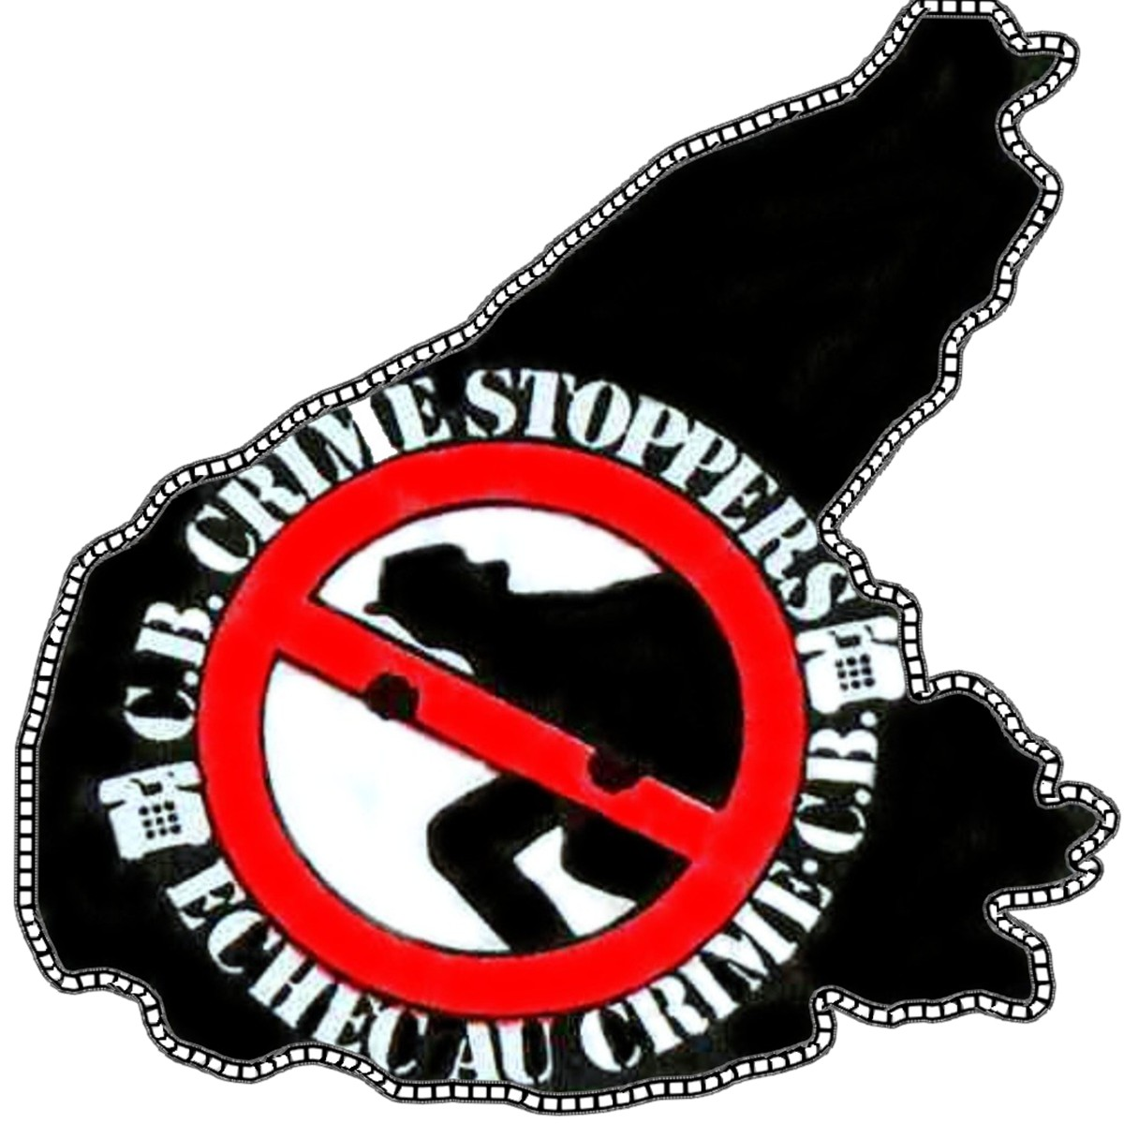

Donation Form

Please help us in our commitment to keep our communities safe from crime. BECOME A CRIME STOPPERS MEMBER - Help Make Your Community A Safer Place to Live

To ensure proper receipt procedure and designation of your donation, please complete the following and include with your gift:

Name and Address Information

Name: _______________________________________________________________________

Address_______________________________________________________________________

City____________________________________PostalCode_____________________________

DaytimeTelephone________________________EveningTelephone_______________________

Email Address ______________________________

If you would like to make a donation to the Crime Stoppers program, please complete the following section:

Donation Total $____________ (Charitable donations in excess of $10 will receive a tax receipt)

Please return completed form with your Cheque made payable to: Cape Breton Crime Stoppers Association

Please copy this page and mail/fax to:

Cape Breton Crime Stoppers Association, 865 Grand Lake Rd. Sydney, N.S. B1P 6W2

Fax: (902) 562-6051 Telephone: (902) 562-8477 Internet: www.capebretoncrimestoppers.ca Email: sydney@capebretoncrimestopppers.ca

