W A N T E D

FOR

Capital Murder
Felony Theft

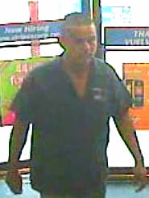

Manuel Enrique Lopez Garcia DOB: 4-26-1986

Height: 5 feet, 6 inches Weight: 180 pounds
Hair: Brown Eye Color: N/A
Tattoos: “Grim Reaper” on right leg Complexion: Medium
Name “Lopez” on back
Name “Manuela” on upper arm

Weslaco, Texas, police hold felony warrants on Manuel Enrique Lopez Garcia, age 22, for charges related to the murder of Roberto Castro, Jr., a 14-year-old boy who was shot and killed at Murphy USA in Weslaco on Saturday, August 23, 2008.

IF YOU HAVE INFORMATION ABOUT THE WHEREABOUTS OF THIS FUGITIVE,
CALL WESLACO POLICE DEPARTMENT INVESTIGATORS AT (956) 968-8591 OR
WESLACO CRIME STOPPERS AT (956) 968-TIPS.

YOU ARE ELIGIBLE FOR A CASH REWARD IF YOUR INFORMATION LEADS TO THE ARREST OF THIS SUSPECT. YOU MAY REMAIN ANONYMOUS.

