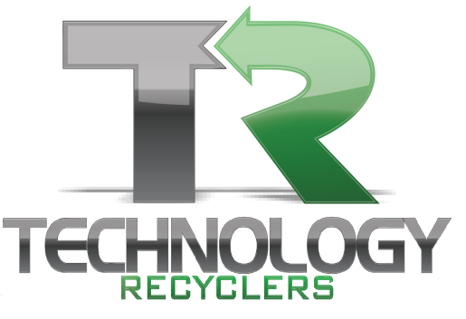

The Official Sponsors of Tomorrow

We are Technology Recyclers; R2 certified- HIPAA, FERPA, DOD and NIST compliant. We service corporate America, large and small businesses with free pickup and destruction. TR specializes and provides recycling services of Computers, Electronics and all IT related E-waste. We also offer local drop off and municipal recycling events.
Now offering Secure, Certified destruction of Distressed, Obsolete or Damaged retail goods.

Our pickups are free, our data destruction is free
Fast, courteous and on time. We are the Easy button for E waste removal and destruction!

Computer Towers Batteries, most all, -please ask
Laptops All Monitors CRT * Flat Panel
Tablets TV’s – Tube Type* LED, LCD, Rear Projection
PDAs VCRs, DVD Players and Game Systems
Cellphones – All Handhelds Satellite TV Equipment, Dish
Pagers, palm pilots, All Telecommunications items, phones, switches
All peripherals Audio Video Equipment
Routers, switches Microwaves, Handheld Appliances
All wiring, All Cable Industrial Electronics, Motors, pumps, light fixtures
Cat 5 cable Industrial Wiring, ballasts (non –PCB)
All computer Room Gear Medical Equipment, lab Equipment
Servers, racks, wire Metal shelving, racking,
Copiers, Printers, scanners Loose Hard Drives, Loose circuit boards and components
All office automation equipment UPS and Backup systems
A/c units, HVAC components

Don’t see a specific item? Please ask

*ALL Monitors and All TV’s – any size have a $20 each fee

WWW.Tech-Recyclers.com
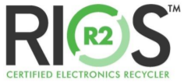
333 S Franklin Road, Indianapolis IN 46219
800.237.3887 Dale@tech-recyclers.com

