CrimeStoppers
NEEDS YOUR HELP

D

Help us solve this case…
East Hanover
On September 20, 2018 at approximately 6:30 pm, an improper touching occurred at a Michael’s store located in the Castle Ridge Shopping Center at 410 Route 10 in East Hanover. A 20 year-old female victim was groped on her buttocks as she was shopping in the store. The victim and witnesses described the suspect as a white male of average height and build, having blonde or orange thinning hair. He had a thin mustache and wore glasses. It appears that he may have a tattoo on his right forearm. He was wearing beige khaki pants and a white short sleeve shirt with what appears to have the Looney Toons cartoon character ‘Gossamer’ printed on it. *Please note the security video images from the store are mirror images.
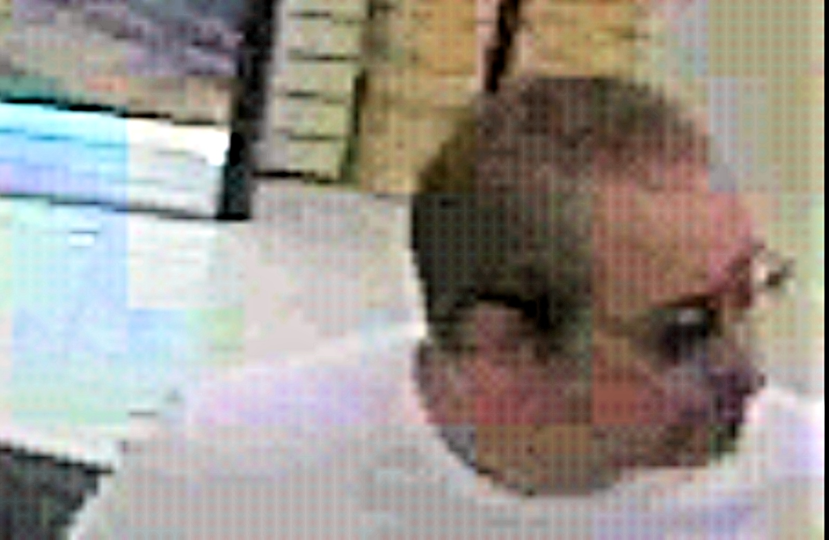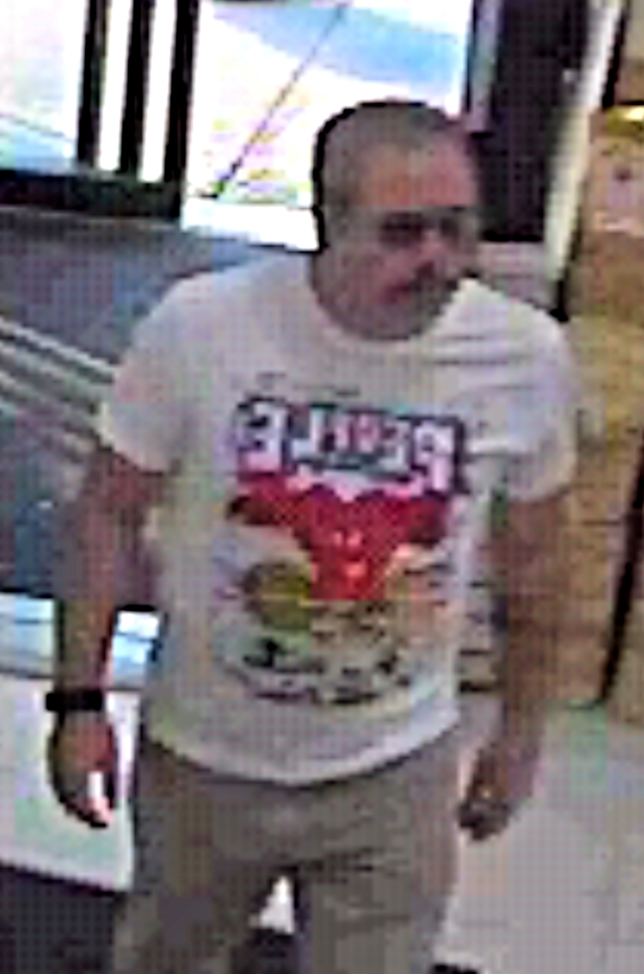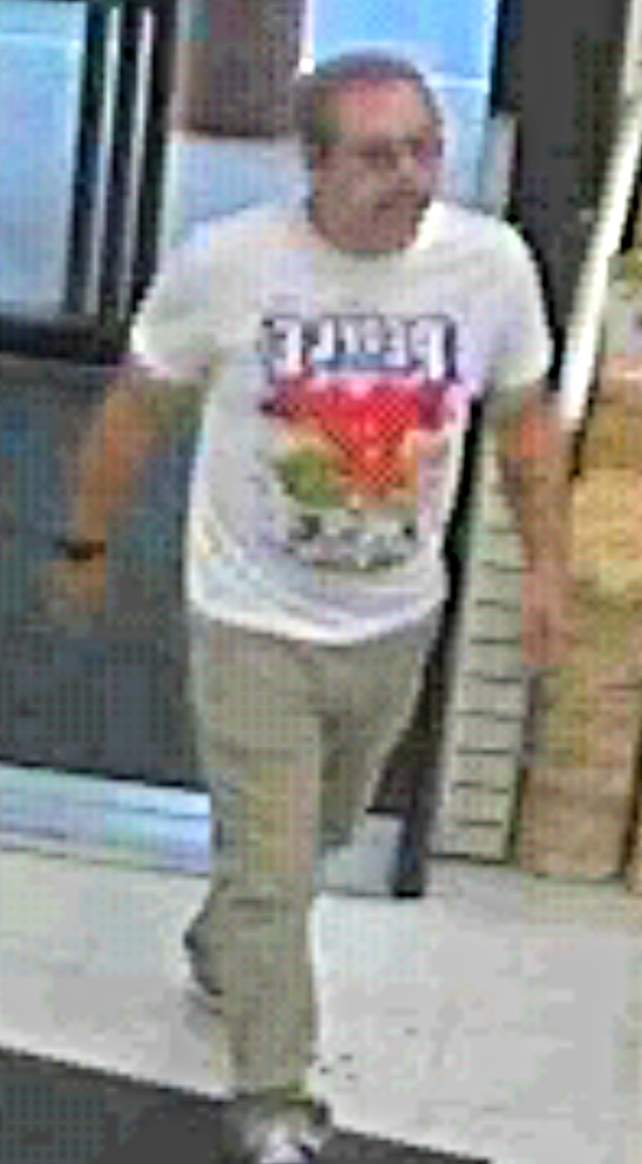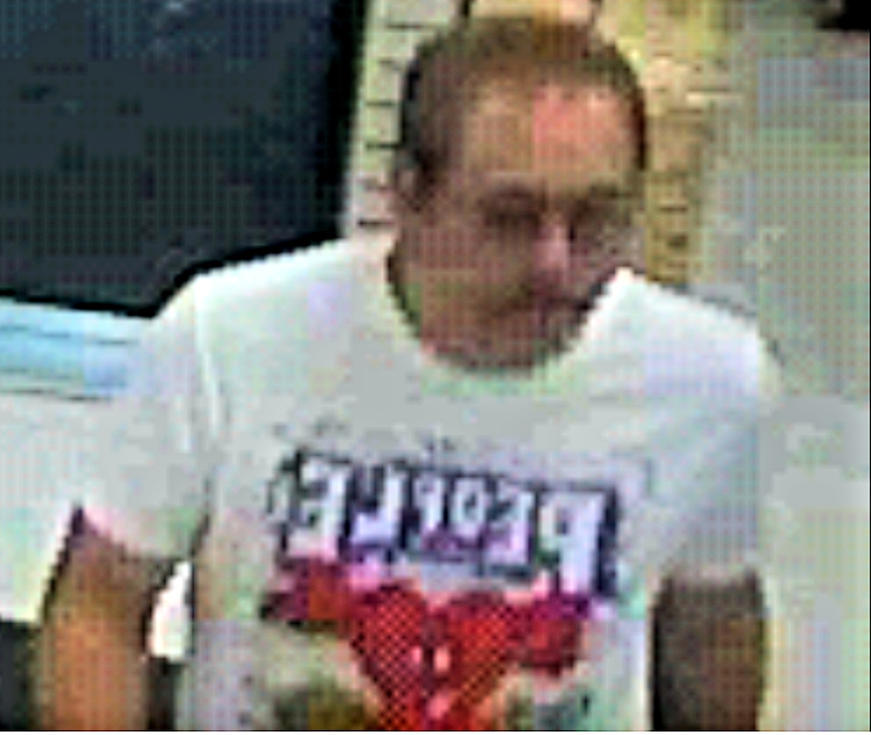
We are asking anyone that may have information to contact
The Morris County Sheriff’s CrimeStoppers at: www.copcall.org
973-COP-CALL or
Use the free “P3 Tips” app on any mobile device
NO ONE WILL ASK YOUR NAME!
YOU could receive a REWARD up to $1,000.00

