
Morris County Sheriff’s CrimeStoppers
Sheriff James M. Gannon
NEEDS YOUR HELP

D

East Hanover
Wanted for the Murder of a three year old child
Edwin Urbina 27 years old
Last Known Address: 14-02 Clyde Potts Drive Morristown NJ
Edwin Urbina is wanted for the fatal beating of a child at the OYO hotel in East Hanover. It is alleged that Edwin Urbina physically beat the three year old boy in the early morning hours of August 13, 2021 resulting in the boy’s death. Urbina is a fugitive at this time. He should not be approached.

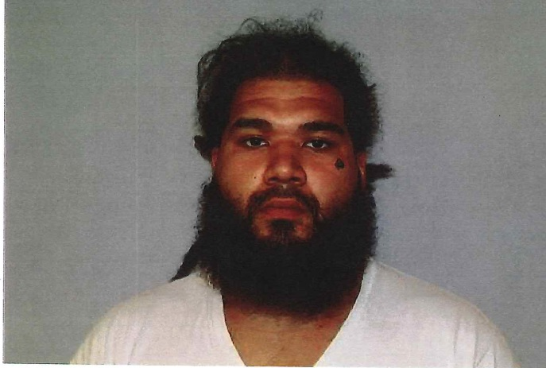
If you have any information contact:
The Morris County Sheriff’s CrimeStoppers at: www.copcall.org
973-COP-CALL or
Use the free “P3 Tips” app on any mobile device
NO ONE WILL ASK YOUR NAME!
YOU could receive a REWARD up to $1,000.00

