CrimeStoppers
NEEDS YOUR HELP

D

Help us solve this case…
Morris Plains
On July 27, 2019 at approximately 1845 hours, three (3) suspects were involved in cutting the power to the Aires Jewelry Store located on the corner of Route 10 East and Harrison Avenue. On video, one male is seen checking out the rear of the store before another male and female return, cut the power box lock and shut down the power to the store. The first male is seen on Harrison Avenue using his cell phone as an apparent lookout. The suspects leave the property without any attempt to gain access to the store. Videos are available and can be provided upon request from Morris Plains PD.
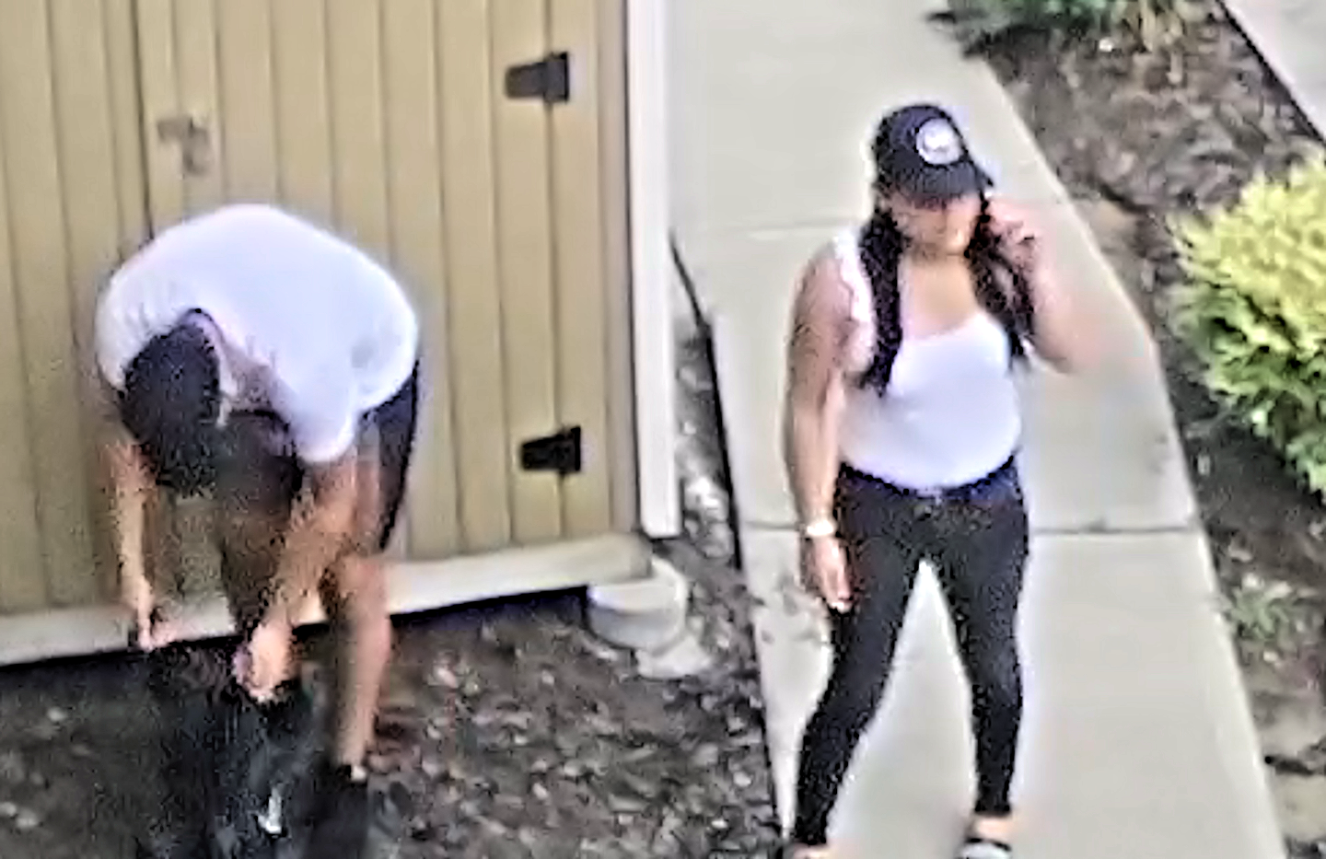

We are asking anyone that may have information to contact
The Morris County Sheriff’s CrimeStoppers at: www.copcall.org
973-COP-CALL or
Use the free “P3 Tips” app on any mobile device
NO ONE WILL ASK YOUR NAME!
YOU could receive a REWARD up to $1,000.00

