10/18/2021
CRIMINAL INVESTIGATIONS DIVISION
CASE # 2021-04170 // AGGRAVATED KIDNAPPING
PLEASE HELP LOCATE THE FOLLOWING SUSPECT:
WANTED
ADRIAN ORNELAS
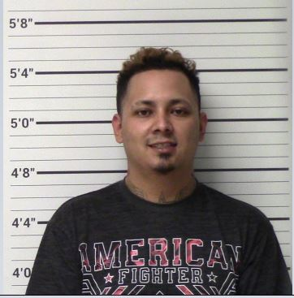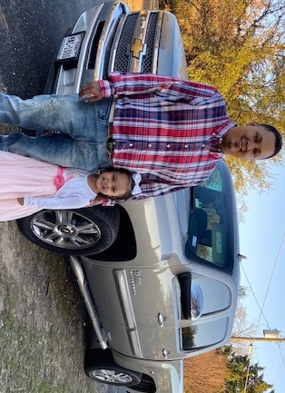

5’6” 180LBS // BRAIDS IN HAIR // DRIVING 2013 TAN CHEVY SILVERADO //
LICENSE PLATE MNC1086

Adrian Ornelas is wanted in connection for an alleged Aggravated Kidnapping that occurred on Saturday 10/16/2021 in the Kerrville area. Adrian has made threats that he will not go to jail alive and is currently on bond awaiting trial for Aggravated Assault with a Deadly Weapon for his alleged involvement of shooting at his ex-girlfriend’s vehicle with his children inside. If Adrian is seen, do not approach or attempt to apprehend. Adrian is believed to be ARMED AND DANGEROUS. Contact 911, the investigator, or report a tip anonymously for the potential of a cash award for information that leads to Adrian’s capture.

Please contact Inv. Jonathan Edwars at 830-315-2452 or Report anonymously to Crime Stoppers for cash reward if suspects are apprehended.

